PLAN DOCUMENT

The high-level flow is depicted below:

1. User needs to set the value of parameters in RIDE configuration file. (This is a one-time configuration file)
2. Host IP –
3. Web API login info -
4. MAC1 -
5. MAC2 -
6. MAC3 –

The below picture will show the “userconfig.txt” file.

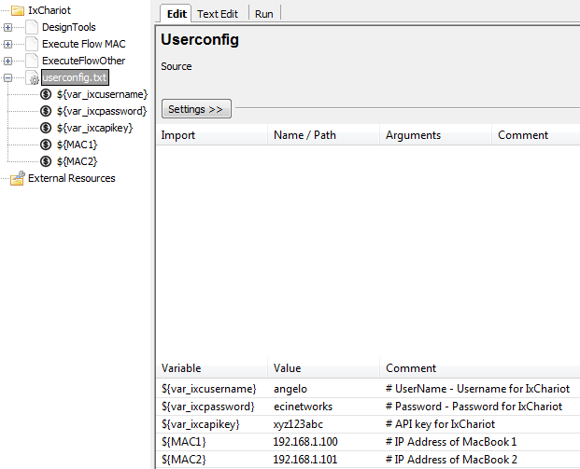

1. Open RIDE GUI and configure the values for the test flow creation.

The user needs to enter the following values for the creation of flow test cases.

1. Flow Group.
2. Test Case name.
3. Endpoint 1.
4. Endpoint 2.
5. Direction.
6. Protocol.
7. Script.
8. Duration (in seconds).
9. Create – Default value to be “Yes”.
10. Number of users.

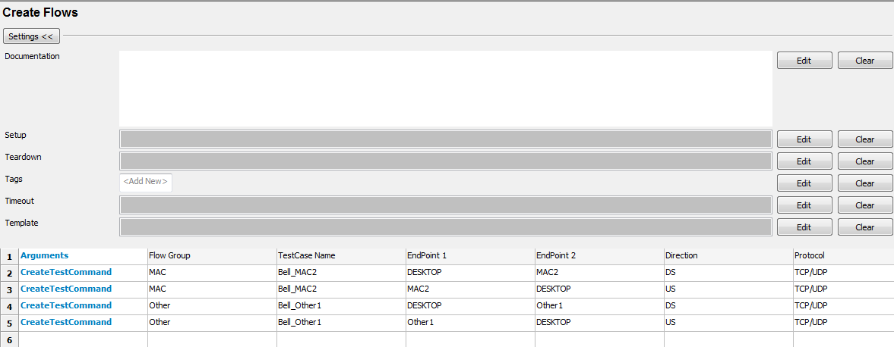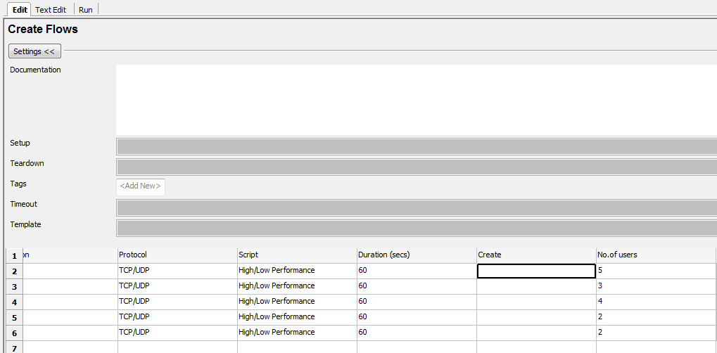

1. The user will then click on the “**Run**” button after providing the values in RIDE.

The values will be read from the configuration and the back end code will start executing.

RIDE will refresh once during this process, where it will close and reopen automatically.

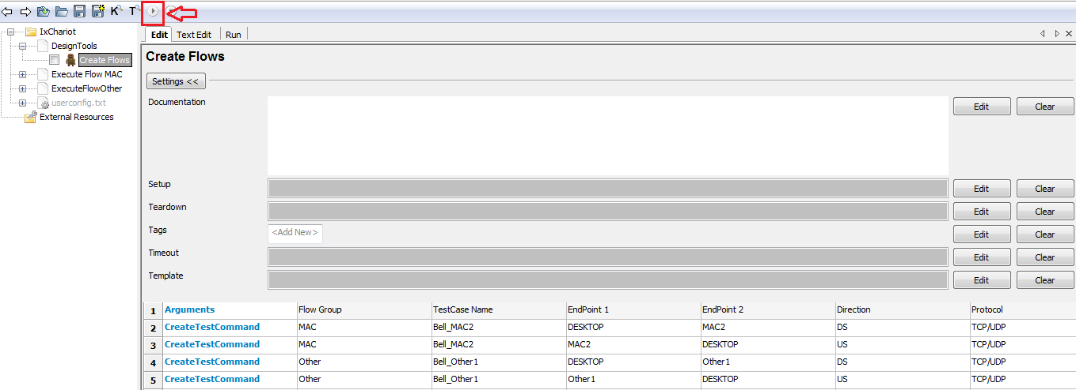

In the background:

Now the back end code will create a Flow Group Python file for each row being configured with values. The entered values will be validated at the first place.

The backend python code will be stored in a folder in the following format.

C: /IxChariot/FlowScripts/<GroupName>/<TestCaseName> + <Direction> .py

Example:

C: /IxChariot/FlowScripts/MAC/Bell_MAC1_DS.py

C: /IxChariot/FlowScripts/MAC/Bell_MAC1_US.py

1. After creating successfully, the user will be able to see the test cases to be executed as shown in the picture below after the RIDE reopens after getting refreshed. It will be grouped based on the “**FlowGroup**” name being entered. The test cases under the groups will be named in the format of <TestCaseName> + <Direction>

Example: MAC1_DS

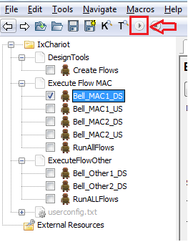

User will be able to choose the Test Flow to be executed and click “**Run**” button which will start the sequential execution of the test cases being marked.

1. In another scenario of test flow execution, the user will also be able execute all the test flows in the particular group without choosing the test cases by clicking on each of them. For this, the user can click on “**ExecuteAllFlows**” and will be able to execute all the flows listed for the particular group.

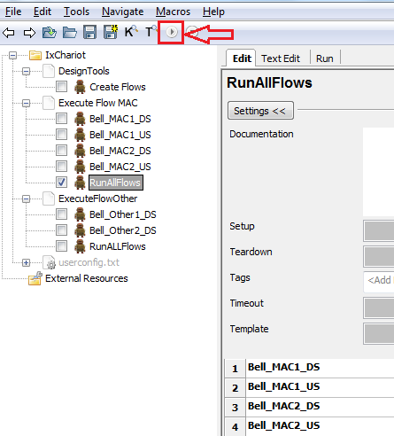

1. The user will be able to view the results of the executions in a specific folder as shown below.

The result file will have a timestamp and will be named as

**“/<Flow Group>/<Direction>/<EndPoint1>/<EndPoint2>_<Script>_<Timestamp>.pdf**”

Example:

C: /IxChariotResults/MAC/DS/DESKTOP/MAC2_TCP_HighPerformance_01012018-130354.pdf

C: /IxChariotResults/MAC/US/MAC2/DESKTOP_TCP_HighPerformance_01012018-130354.pdf

The user will also have the **.csv report files** in a **zip** format with the same naming convention.

C: /IxChariotResults/MAC/DS/DESKTOP/MAC2_TCP _HighPerformance_01012018-130354.zip

C: /IxChariotResults/MAC/US/MAC2/DESKTOP_TCP _HighPerformance_01012018-130354.zip

**Note**: The WebAPI version creates the .csv files inside a zip folder.

1. Log Files

The user will be able to see the detailed log files for the entire process. This will help the user to understand the steps being executed and will also help to understand the cause of problem if any.

The log file will be stored in “**C:\IxChariot\Logs”**

The log file will be generated each day the user executes IxChariot test cases using the automation solution. All the steps executed on the automation solution will be logged in the same file.

The naming convention for the log file will be “**DetailLog<DDMMYYYY-HHMMSS>.log**”.

1. Report Files

The user will be able to see the report file of RIDE automation execution after every execution. The user should click on the “**Report**” or “**Log**” button on the RIDE GUI.

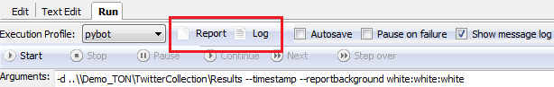

The user will also be able to view the report/log files any time later from the folder “**C:\IxChariot\Results\**”.